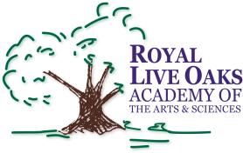 1398 Church Road, Hardeeville, SC 29927 • 843-784-2630 • www.rloacs.org

AGENDA

The Royal Live Oaks Academy of Arts & Sciences Charter School Board Meeting
October 22, 2015 6:30pm
Student Dining Hall

- Old business:

  - Approval of Minutes of September 15, 2015 meeting - Secretary

- New business:

  - RLOA Mission Statement - Chair

  - September Finance Report - Bill Moser, Kelly-Moser Consulting

  - Update on Two Modulars and on New Campus - Facilities Development Company

  - USDA Loan for New Campus Project: Loan Resolution and Letter of Condition – Rusty Craven, USDA Walterboro Office

  - Close-Up Washington Field Trip Presentation – Student Government Representatives

  - School Updates – Executive Director

  - Ballot for Upcoming Board Election - Nominating Committee

- Public Comment

- Adjournment

