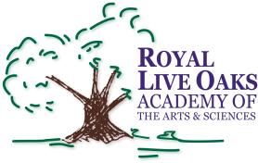 1398 Church Road, Hardeeville, SC 29927 • 843-784-2630 • www.rloacs.org

AGENDA

The Royal Live Oaks Academy of Arts & Sciences Charter School Board Meeting
September 20, 2016 6:30pm
Student Dining Hall

- Old business:

  - Approval of Minutes of August 16, 2016 meeting - Secretary

- New business:

  - RLOA Mission Statement - Chair

  - August Finance Report and Updated FY17 Budget- Bill Moser, Kelly-Moser Consulting

  - Update on New Campus Financing - Facilities Development Company and New Campus Bond Financing Team Member

  - Approval of Authorizing Resolution for Bond Notes

  - School Updates – Executive Director and Elementary Assistant Principal

  - Missing Board Seat

- Public Comment

- Adjournment

