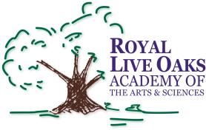 1398 Church Road, Hardeeville, SC 29927 • 843-784-2630 • www.rloacs.org

AGENDA

The Royal Live Oaks Academy of Arts & Sciences Charter School Board Meeting
August 18, 2015 6:30pm
Student Dining Hall

- Old business:

  - Approval of Minutes of June 16, 2015 meeting - Secretary

- New business:

  - RLOA Mission Statement - Chair

  - June Finance Report - Bill Moser, Kelly-Moser Consulting

  - July Finance Report – Bill Moser, Kelly-Moser Consulting

  - Report on Independent CPAs Analysis of Performance Framework Profile Financial Formula - Bill Moser

  - Update on Two New Modulars and on New Campus - Facilities Development Company

  - Report on Charter School Alliance Meeting – Boards, Charter School Accreditation, SCPCSD, Legislative Actions - Executive Director

  - Addition to Employee Handbook: Appendix D – Executive Director

  - Updated Charter Goals and Objectives: Charter Amendment - Executive Director

  - School Updates – Executive Director

  - Updated Safety Measures in Employee Handbook – Executive Director

  - Updated By-Laws – Executive Director

  - Open Board Seat – Chair

- Public Comment

- Adjournment

