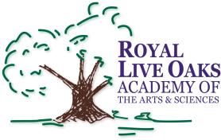 1398 Church Road, Hardeeville, SC 29927 • 843-784-2630 • www.rloacs.org

AGENDA

The Royal Live Oaks Academy of Arts & Sciences Charter School Board Meeting
January 17, 2017 6:30pm
Student Dining Hall

- Call to Order and Approval of Agenda

- Approval of November 15, 2016 Minutes - Secretary

- Public Comment

  - RLOA Mission Statement – Chair

  - November and December Finance Reports - Bill Moser, Kelly-Moser Consulting

  - Update on New Campus Financing – Executive Director and Facilities Development Company

  - Board Election Results: Counting of Ballots - Secretary

  - Appointment of Missing Board Seat - Chair

  - Confirmation of New Board Members - Chair

  - Election of Officers - Chair

  - School Updates – Executive Director

- Adjournment

